Backlog and epics:
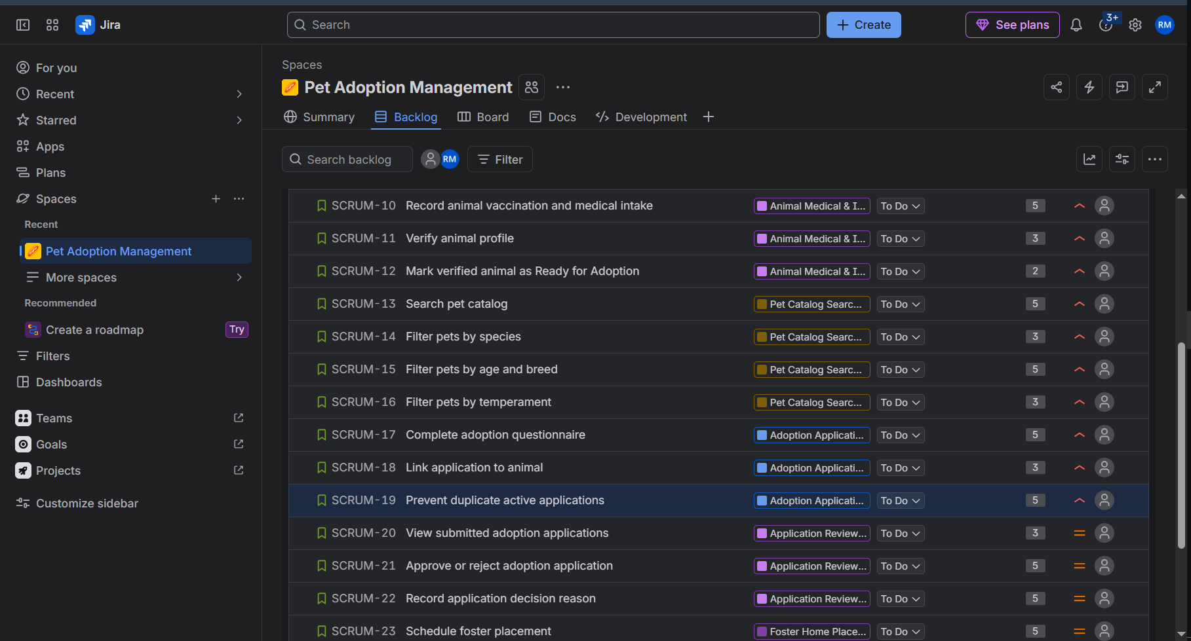

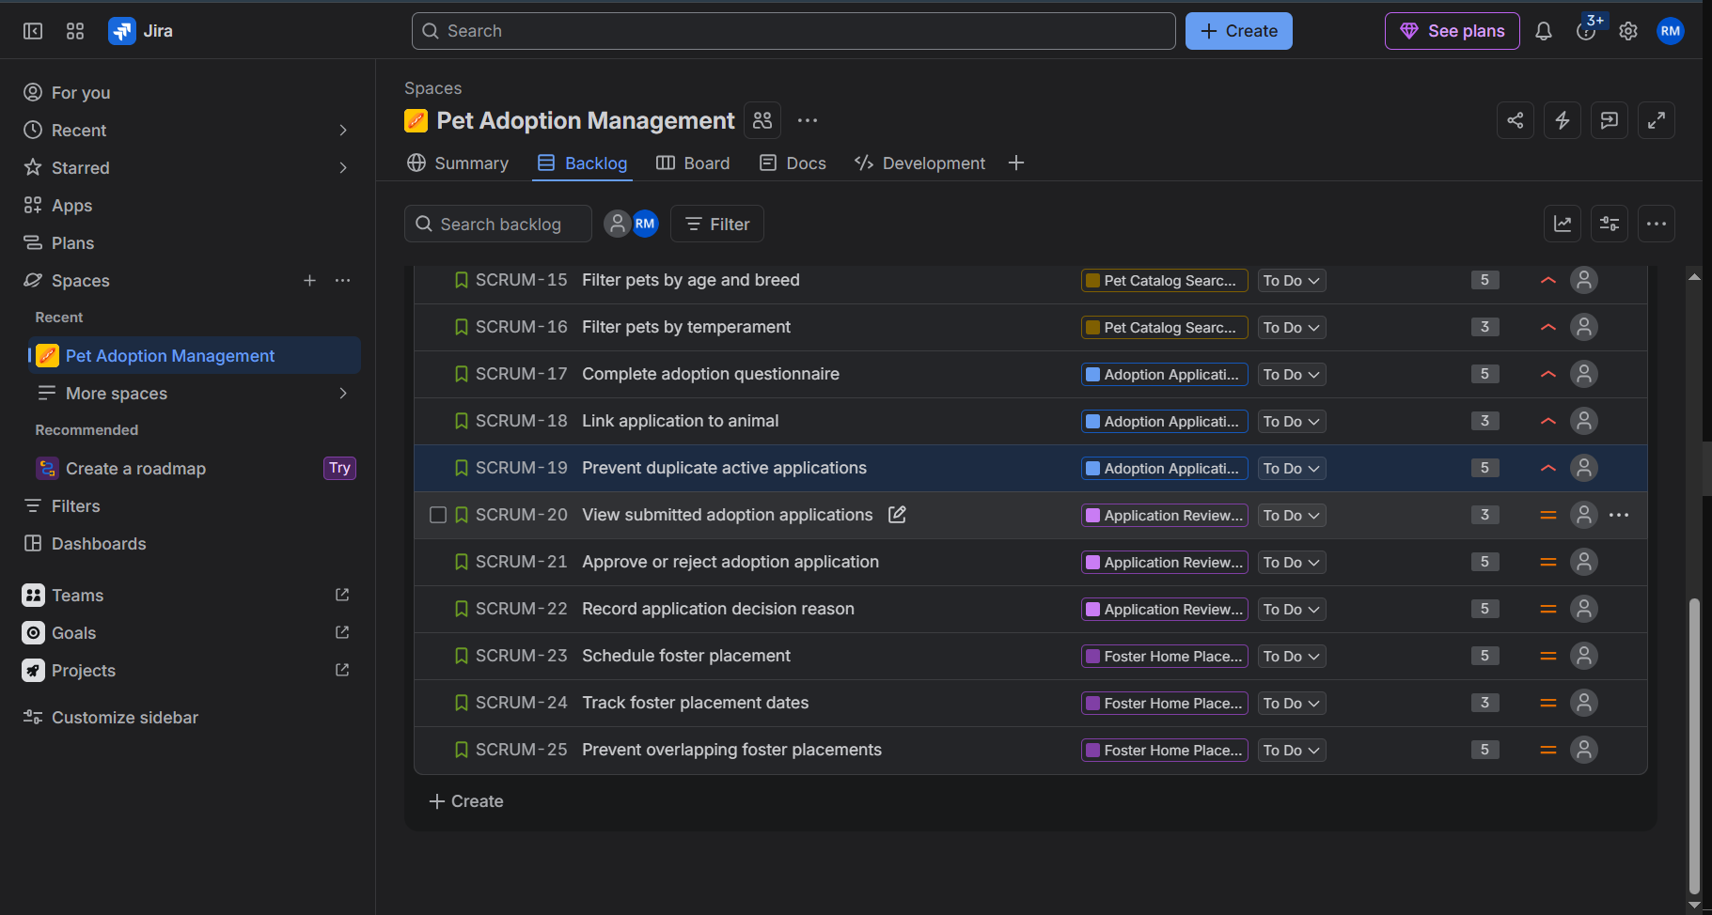

5 epics

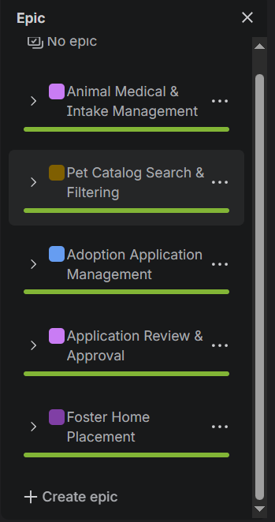

Sprint 1
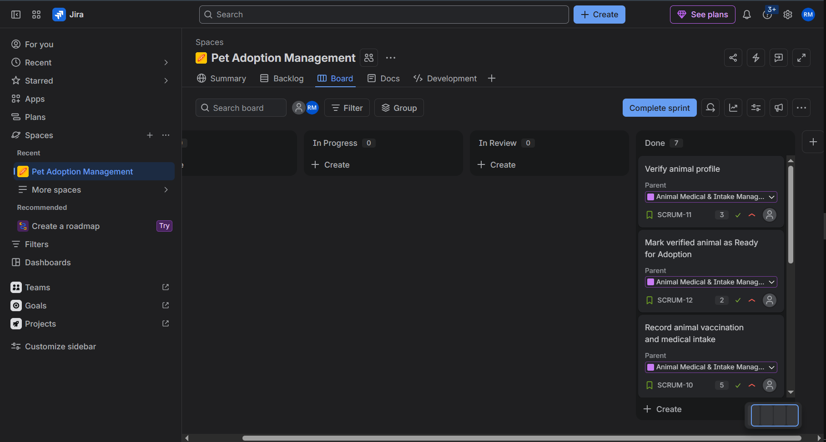

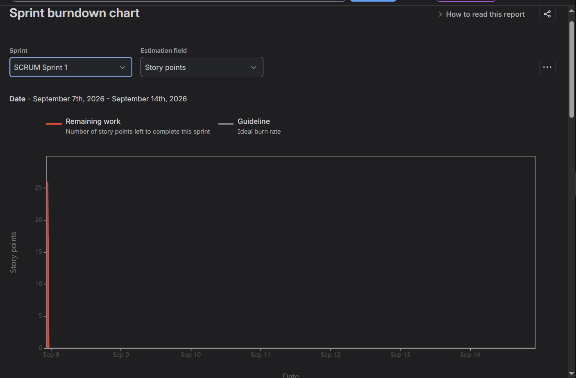

Sprint 2
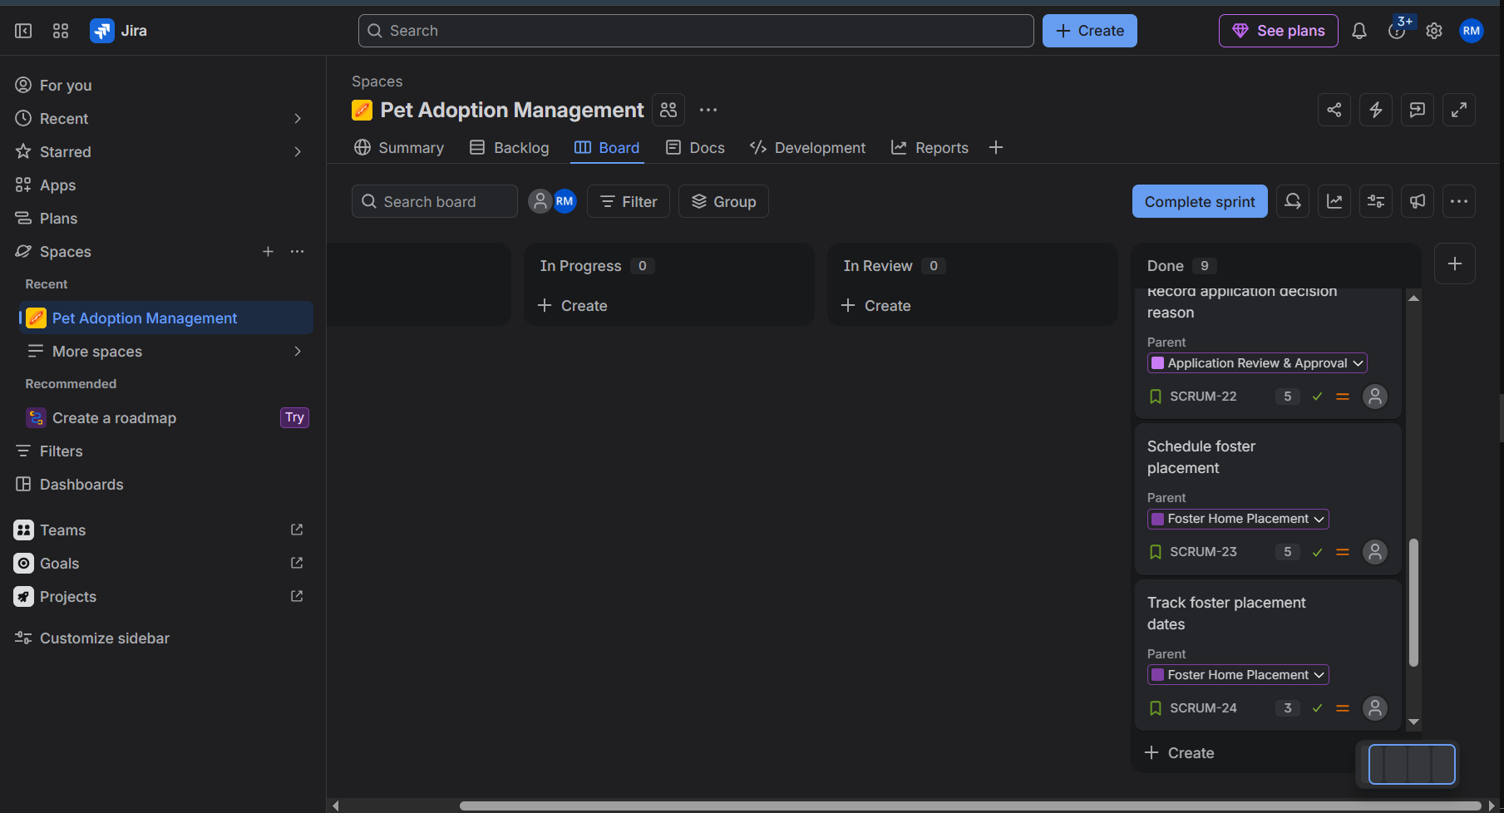

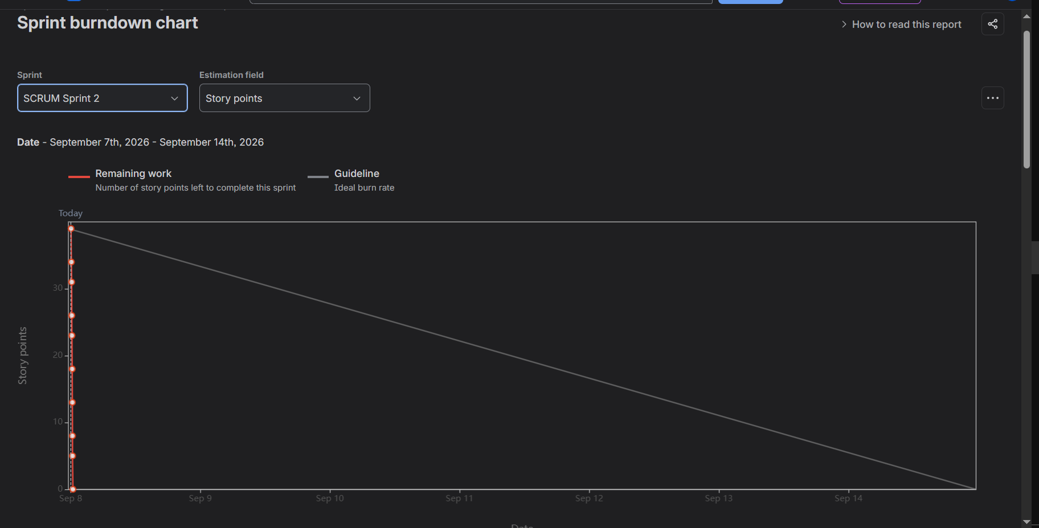

1. Did the story point estimations reflect the actual effort?
Yes. The story points reasonably reflected the relative effort and complexity of each task. Simpler tasks received 2–3 points, while more complex tasks received 5 points. The total backlog was 65 points, divided between Sprint 1 (31 points) and Sprint 2 (34 points).

2. Was the backlog well-prioritized?
Yes. The backlog was prioritized based on the importance of the functional requirements. Core features such as medical records, pet search, and adoption applications were given High priority, while application review and foster placement were Medium priority.

3. How did the simulated sprint align with the initial plan?
The sprints closely followed the initial plan. 8 stories (31 points) were completed in Sprint 1 and the remaining 8 stories (34 points) in Sprint 2. The stories were moved through To Do → In Progress → Done as planned.

4. What insights did the burndown chart provide about team capacity?
The burndown chart showed how the remaining Story Points decreased as work was completed. It helped visualize sprint progress and compare the team's actual progress with the planned workload, providing an understanding of the team's capacity.

